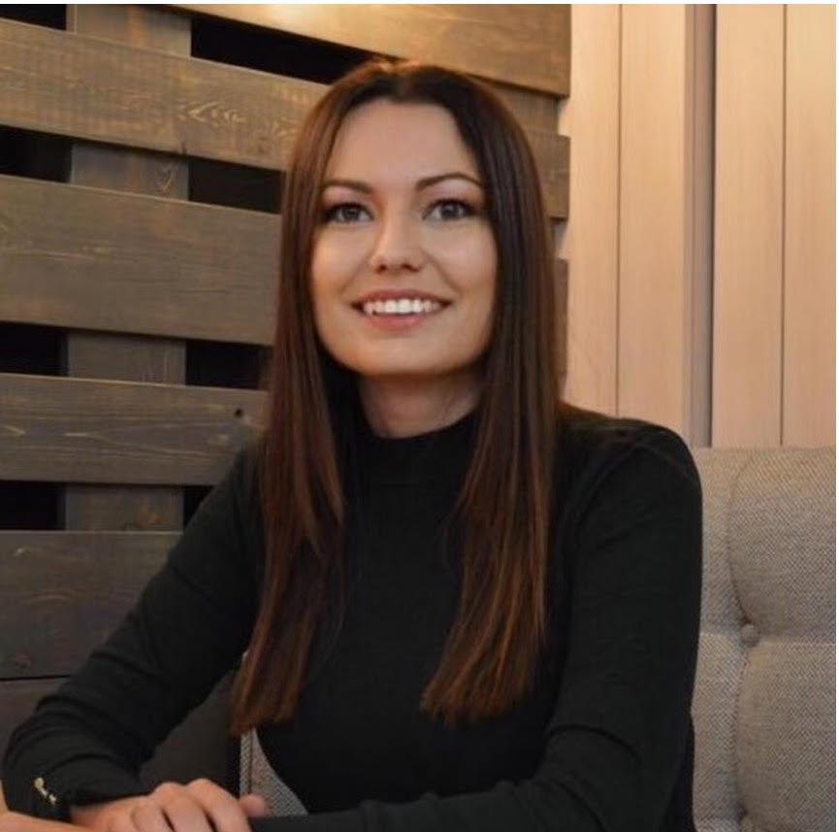

**WORK EXPERIENCE**

**DIPLOMAS Y HOBBIES**

**Formaciones :** Diplomados, Congresos, xxxxxxxxxx xxxxxx xxxxxxxxx xxxxxxxxxxxxxxxxx

**Hobbies:** xxxxxxxxxxxxxxxxxxxxxxxxxxxxxx

**NATALI TRAVEL LLC | 2022 – until now**

QA engineer, Moscow

Tasks:

**INDIVIDUAL ENTREPRENEUR LARIONOVA IULIIA MIKHAILOVNA | 2020 – 2022**

QA engineer, Moscow

Tasks:

**IULIIA**

**LARIONOVA**

QA engineer

**ABOUT ME**

I am QA engineer with three years of experience testing desctop applications, websites, UI/UX, API.

I will glad to join your team.

Let’s make quality product together.

**SKILLS**



* Teamwork
* Communication
* Organization
* Emotional Intelligence
* Conflict Resolution

English: Advanced

Russian: Native

**LANGUAGES**

**CONTACT**

+7 927 765-54-05

kometerra@gmail.com

Moscow, Russia

©AZURIUS - My-resume-templates.com